Full Stack Development with MERN
1. Introduction
• Project Title: [Your Project Title]
• Team Members: List team members and their roles.
2. Project Overview
• Purpose: Briefly describe the purpose and goals of the project.
• Features: Highlight key features and functionalities.
3. Architecture
• Frontend: Describe the frontend architecture using React.
• Backend: Outline the backend architecture using Node.js and Express.js.
• Database: Detail the database schema and interactions with MongoDB.
4. Setup Instructions
• Prerequisites: List software dependencies (e.g., Node.js, MongoDB).
• Installation: Step-by-step guide to clone, install dependencies, and set up the
environment variables.
5. Folder Structure
• Client: Describe the structure of the React frontend.
• Server: Explain the organization of the Node.js backend.
6. Running the Application
• Provide commands to start the frontend and backend servers locally.
o Frontend: npm start in the client directory.
o Backend: npm start in the server directory.
7. API Documentation
• Document all endpoints exposed by the backend.
• Include request methods, parameters, and example responses.
8. Authentication
• Explain how authentication and authorization are handled in the project.
• Include details about tokens, sessions, or any other methods used.
9. User Interface
Provide screenshots or GIFs showcasing different UI features.
10. Testing
• Describe the testing strategy and tools used.
11. Screenshots or Demo
• Provide screenshots or a link to a demo to showcase the application.
12. Known Issues
• Document any known bugs or issues that users or developers should be aware of.
13. Future Enhancements
• Outline potential future features or improvements that could be made to the project.
1. INTRODUCTION
Project Title
ShopEZ – A Full Stack E-commerce Web Application using the MERN Stack
Objective
The aim of this document is to provide a detailed overview and technical description of the ShopEZ project, a modern e-commerce web application developed using the MERN (MongoDB, Express.js, React.js, Node.js) stack. This documentation serves as a comprehensive guide for understanding the application architecture, development approach, and deployment methodology. It will also support future developers in extending or maintaining the project with ease.
Background
Online shopping platforms have become a necessity in the modern digital world. With the growth of internet access and mobile technology, e-commerce solutions must be fast, scalable, secure, and user-friendly. ShopEZ is built to demonstrate a fully functional, scalable, and modular e-commerce platform that serves both users and sellers effectively.
Motivation
As full stack developers, our goal was to understand and implement a complete end-to-end application using modern JavaScript technologies. This project allowed us to dive deep into real-world full-stack application challenges including REST API integration, authentication, state management, and deployment. ShopEZ not only solidifies technical skills but also showcases a deployable solution fit for portfolio or commercial use.
Technologies Used
- React.js for frontend development
- Node.js and Express.js for backend API development
- MongoDB for database storage
- JWT for authentication and security
- Tailwind CSS for UI styling
- Git & GitHub for version control and collaboration
- Render/Netlify for deployment

Team Members and Their Roles
Name | Role | Responsibilities
Vulli Yuthika | Full Stack Developer | Designed frontend components using React, integrated backend API, implemented authentication and authorization
Veeroji Kiran | Backend Engineer | Developed RESTful APIs, created MongoDB schema and implemented secure user login and registration systems
Varshitha Talasila | UI/UX Designer | Designed wireframes and enhanced UI/UX with responsive layouts
Velchuri Mahesh | Deployment Specialist | Managed deployment process using Render and Netlify, configured environment variables and CI/CD pipelines
Development Approach
The project followed a modular and component-based development approach. Agile methodology was adopted, with tasks divided into sprints that allowed for iterative development and regular reviews. Version control was strictly maintained using Git, and all major changes were peer-reviewed before merging.
Goals of the Project
- Develop a responsive and scalable e-commerce platform
- Implement role-based authentication for users and sellers
- Enable cart and checkout functionality with dynamic state updates
- Create a clean and modern UI that is easy to navigate
- Provide seller dashboards with analytics and product management tools
- Ensure smooth deployment and hosting for public access

2. PROJECT OVERVIEW
Purpose
The primary purpose of the ShopEZ project is to develop a complete e-commerce web application that delivers a seamless and intuitive shopping experience for both users and sellers. The system is designed using the MERN (MongoDB, Express.js, React.js, Node.js) stack to ensure a full stack JavaScript solution that is modern, scalable, and maintainable.
The application provides a dynamic and interactive front end using React, a robust and secure backend using Express and Node.js, and a flexible NoSQL database using MongoDB. This setup enables rapid development and easy integration of features such as authentication, shopping cart, checkout, and product management.
Goals of the Project
- Build a modular, scalable e-commerce application.
- Provide essential features of a commercial online shopping platform.
- Use modern development best practices for full stack development.
- Ensure clean, responsive UI and mobile-friendly experience.
- Implement secure user authentication and authorization mechanisms.
- Deploy the platform for public access and real-world testing.

Features
The ShopEZ application is designed to simulate a real-world online marketplace. Below are the major features categorized for Users, Sellers, and Admin Functions.
A. User Features
Feature | Description
User Registration | New users can sign up with email, username, and password.
Login & Logout | Secure login using JWT authentication; logout clears user session.
Product Listing | Users can browse through a list of available products with details.
Product Details View | Clicking on a product shows a detailed page including image, description, and price.
Search & Filter | Users can search products and apply filters (by category, price).
Add to Cart | Logged-in users can add products to their cart.
Cart Management | View, update, and remove items in the cart dynamically.
Checkout | Users can proceed to checkout and view summary of purchase.

B. Seller Features
Feature | Description
Seller Registration | Sellers can register and request product listing privileges.
Product Management | Add, edit, and delete products directly from the seller dashboard.
View Orders | Sellers can view purchase orders made on their products.
Analytics Dashboard | Track number of orders, revenue, and popular products.

C. Admin/Backend Capabilities
Feature | Description
User Authentication | Handles secure token-based login and access control.
Role-Based Access | Users and sellers have different access rights.
API Endpoints | RESTful API for all frontend interactions.
Database Management | MongoDB used to persist user data, product info, and orders.

Here is the 3. Architecture section formatted for your documentation. It’s designed to span approximately 2 pages when placed in Microsoft Word, using bold headings, structured content, and clean paragraph formatting suitable for professional project documentation.

3. ARCHITECTURE

Frontend Architecture (React.js)
The frontend of the ShopEZ application is developed using React.js, a powerful JavaScript library for building user interfaces. The design philosophy of the frontend focuses on component-based architecture, state management, and reactive rendering, allowing efficient handling of dynamic user interactions.
Key Components of the Frontend:
- Component-Based UI: Each section of the user interface is divided into modular and reusable components such as Navbar, Footer, ProductCard, Home, Login, Register, and Cart.
- Routing: The application uses React Router DOM to handle client-side routing, enabling seamless navigation between pages like Home, Product Details, Login, Register, and Cart.
- State Management: The global state is managed using React Context API, particularly for auth (authentication context) and cart (cart context). This helps in maintaining and sharing state across components without prop drilling.
- Styling: Styling is achieved using Tailwind CSS for fast, utility-first, and responsive design. It ensures a mobile-friendly interface and consistent styling throughout the application.
- Authentication Handling: The frontend uses JWT tokens received from the backend and stores them in localStorage. These tokens are used to validate user sessions and protect private routes.

Diagram: React Frontend Structure
src/
│
├── assets/ → Static images and styles
├── components/ → Reusable UI elements (Navbar, ProductCard)
├── pages/ → Page-level components (Home, Login, Cart)
├── context/ → Auth and Cart context providers
├── App.js → Root component with routing
└── index.js → Entry point

Backend Architecture (Node.js + Express.js)
The backend of the application is built using Node.js and Express.js, which together provide a robust and scalable server-side platform. It acts as a bridge between the React frontend and the MongoDB database, processing requests, managing authentication, and handling business logic.
Key Features of Backend:
- Express Router: All routes are modularized in separate route files such as user.routes.js and product.routes.js. These are linked to their respective controllers to handle requests and responses.
- Controller-Based Logic: Business logic is separated into controller files. For example, user registration and login are handled in user.controller.js.
- Middleware: The backend includes custom middleware functions for handling errors and protecting routes (authMiddleware.js).
- Security: Passwords are hashed using bcryptjs, and jsonwebtoken (JWT) is used for session management and secure authentication.
- Environment Configuration: Sensitive information such as MongoDB URI and JWT secret is stored in a .env file and accessed securely using the dotenv package.
Diagram: Node.js Backend Structure
server/
│
├── controllers/ → Business logic (user.controller.js, product.controller.js)
├── models/ → Mongoose schemas (user.model.js, product.model.js)
├── routes/ → Express route definitions
├── middleware/ → Auth middleware, error handling
├── db.js → MongoDB connection file
├── server.js → Main entry point to start the backend server
└── .env → Environment variables

Database Design (MongoDB)
The database used is MongoDB, a NoSQL database that stores data in JSON-like documents. It provides high flexibility and scalability for dynamic content such as user profiles, product listings, and orders.
Key Collections in MongoDB:
Collection | Description
users | Stores user credentials, names, roles (user/seller).
products | Contains product details such as name, price, image.
orders | Stores user orders including cart items and totals.
Sample Schema: User
const userSchema = new mongoose.Schema({
name: String,
email: { type: String, unique: true },
password: String,
role: { type: String, default: 'user' }
}, { timestamps: true });
Database Interaction
- The backend uses Mongoose, an ODM (Object Data Modeling) library, to define schemas and interact with the database.
- Each schema defines the structure of the documents stored in a collection.
- CRUD operations are performed using Mongoose methods like .find(), .save(), .findByIdAndUpdate(), and .deleteOne().

Here is the 4. Setup Instructions section of your documentation, formatted professionally and designed to fill 2 Word document pages with detailed instructions, clear structure, and no special symbols.

4. SETUP INSTRUCTIONS

Prerequisites
Before running the ShopEZ MERN stack application, ensure that the following software and tools are installed on your system:
Software Dependencies
Software | Version (Recommended) | Purpose
Node.js | 18.x or later | JavaScript runtime to run backend and frontend
npm (Node Package Manager) | Comes with Node.js | Install dependencies for client/server
MongoDB | 6.x or later | NoSQL database to store user and product data
Git | Latest | To clone the project repository
Visual Studio Code (VS Code) | Latest | Source code editor for development
Postman | Optional | API testing tool
Web Browser | Chrome/Edge/Firefox | To view the frontend
System Requirements
- Operating System: Windows 10/11, macOS, or any Linux distro
- Minimum RAM: 4 GB (8 GB recommended)
- Disk Space: At least 500 MB for dependencies and database files

Installation Steps
Follow the steps below to clone and run the ShopEZ project on your local machine.
Step 1: Clone the Repository
Open a terminal or Git Bash and run the following command:
git clone https://github.com/VelchuriMahesh/ShopEZ.git
This will download the project files into a folder named ShopEZ.
Step 2: Navigate to Project Folders
cd ShopEZ
There are two main directories:
- client – contains the React frontend code.
- server – contains the Node.js backend code.

Step 3: Install Dependencies
Backend Setup
cd server
npm install
This will install all required Node.js modules such as express, mongoose, cors, dotenv, bcryptjs, and jsonwebtoken.
Frontend Setup
In a new terminal window or tab:
cd client
npm install
This installs React-related dependencies such as react-router-dom, axios, tailwindcss, and context providers.

Step 4: Configure Environment Variables
Create a .env file in the server directory with the following content:
PORT=5000
MONGO_URI=mongodb://localhost:27017/shopez
JWT_SECRET=your_jwt_secret_here
Replace your_jwt_secret_here with a secure random string.
Ensure that MongoDB is running locally on port 27017 or update the URI accordingly.

Step 5: Start MongoDB Server
Make sure MongoDB is running. You can use one of the following methods:
- For Windows:
- net start MongoDB
- For macOS/Linux (using brew or service):
- brew services start mongodb-community

Step 6: Run the Application
Start the backend server:
cd server
npm start
Start the frontend development server:
cd client
npm start
The frontend will start at http://localhost:3000
The backend will run on http://localhost:5000

Optional: Seed Sample Product Data
To populate the MongoDB database with sample products:
- Ensure MongoDB and backend are running.
- In the server directory, run:
node seed.js
This will insert predefined sample products into the database for testing.

Here is the 5. Folder Structure section for your MERN Stack Project Documentation. It is formatted clearly and detailed enough to cover 2 pages in a Word document, using bold headings and structured explanations.

5. FOLDER STRUCTURE

Client Directory (Frontend – React)
Path: ShopEZ/client/
The client directory contains all the code related to the user interface. It is built using React.js, with support for routing, state management, and API integration.
Folder Structure Overview:
Folder/File | Description
public/ | Contains static files like index.html and icons.
src/ | Main source code of the React app.
src/assets/ | Stores image assets used in the frontend.
src/components/ | Reusable UI components like Navbar, ProductCard, etc.
src/pages/ | Page-level components like Home, Login, Register, Cart.
src/context/ | React context for global state (Auth, Cart).
src/App.js | Root component containing the main router.
src/index.js | Entry point that renders the React app.
tailwind.config.js | Tailwind CSS configuration.
package.json | Lists React-related dependencies.
Important Files:
- App.js – Configures routes and layout of the application.
- index.js – Initializes the React DOM and wraps the app in providers.
- ProductCard.jsx – Component to render product preview cards.
- AuthContext.js – Manages authentication state using React Context.
- CartContext.js – Provides cart functionality across the app.

Server Directory (Backend – Node.js + Express)
Path: ShopEZ/server/
The server directory handles all backend logic including routing, authentication, database interaction, and APIs.
Folder Structure Overview:
Folder/File | Description
models/ | Contains Mongoose schema definitions for MongoDB collections.
routes/ | Defines RESTful API endpoints for products and users.
controllers/ | Logic for handling requests (e.g., registering users, adding products).
middleware/ | Middleware functions such as authentication checks.
db.js | MongoDB connection using Mongoose.
server.js | Main entry point of the Express application.
seed.js | Script for seeding initial product data.
.env | Stores environment variables like MongoDB URI and JWT secret.
package.json | Lists backend dependencies.
Important Files Explained:
- server.js – Initializes the Express app, configures middleware, and sets up routes.
- product.model.js – Defines the structure for product documents in MongoDB.
- user.model.js – Schema for user registration and login.
- user.controller.js – Handles user registration, login, and token generation.
- auth.middleware.js – Verifies JWT tokens for protected routes.

Summary Table
Layer | Technology | Entry File | Main Folder
Frontend | React.js | index.js | client/src/
Backend | Node.js, Express.js | server.js | server/
Database | MongoDB | MONGO_URI (in .env) | via models/

Here is the 6. Running the Application section for your MERN Stack Project Documentation. This section is detailed to cover 1–2 pages in a Word document and is formatted clearly with bold headings, commands, and explanations.

6. RUNNING THE APPLICATION

After successfully setting up all dependencies and environment variables, the next step is to run the application locally for development and testing. This section outlines the procedures to start both the frontend (React) and backend (Node.js + Express) servers independently.

Backend Server (Express + Node.js)
The backend server handles API requests, connects to the MongoDB database, and manages authentication, product operations, and user data.
Steps to Run the Backend Server:
- Navigate to the server directory:
- cd ShopEZ/server
- Start the server using npm:
- npm start
- Expected Output:
Once started, the console should log:
- 🚀 Server running on http://localhost:5000
- Important Note:
Ensure MongoDB is running locally or the MONGO_URI in your .env file points to an active MongoDB Atlas cluster.

Frontend Server (React.js)
The frontend provides the user interface, fetches data from the backend API, and enables user interactions such as viewing products, logging in, and adding items to the cart.
Steps to Run the Frontend Server:
- Navigate to the client directory:
- cd ShopEZ/client
- Start the frontend server using npm:
- npm start
- Expected Output:
This command will open your default browser at:
- http://localhost:3000
You will see the homepage of the ShopEZ application.
- Proxy Configuration:
Make sure the proxy is set in client/package.json to redirect API requests to the backend:
- "proxy": "http://localhost:5000"

Running Both Servers Simultaneously
If you'd like to run both frontend and backend together efficiently during development:
- Open two terminal windows or tabs:
  - One for ShopEZ/server
  - One for ShopEZ/client
- Run npm start in each directory as described above.
Optional Tools:
Tool | Purpose
Nodemon | Automatically restarts backend server on changes.
React DevTools | Inspect React components in the browser.

Summary of Commands:
Component | Directory | Command | Port
Backend | ShopEZ/server | npm start | http://localhost:5000
Frontend | ShopEZ/client | npm start | http://localhost:3000

Here is the 7. API Documentation section, written in a clear project documentation format suitable for Word, with bold headings, structured content, and detailed endpoint specifications for your ShopEZ MERN stack project.

7. API DOCUMENTATION

The backend of the ShopEZ project exposes multiple RESTful API endpoints to handle user authentication, product management, and cart operations. These APIs are structured to support both frontend interaction and future scalability.

Base URL
http://localhost:5000/api

7.1 User Authentication Endpoints
1. Register a New User
- Endpoint: /api/users/register
- Method: POST
- Description: Creates a new user in the system.
- Request Body:
{
"name": "Mahesh",
"email": "mahesh@example.com",
"password": "123456"
}
- Response:
{
"_id": "6855076f9d8518425fdacb31",
"name": "Mahesh",
"email": "mahesh@example.com",
"token": "eyJhbGciOiJIUzI1..."
}

2. Login a User
- Endpoint: /api/users/login
- Method: POST
- Description: Authenticates a user and returns a token.
- Request Body:
{
"email": "mahesh@example.com",
"password": "123456"
}
- Response:
{
"_id": "6855076f9d8518425fdacb31",
"name": "Mahesh",
"email": "mahesh@example.com",
"token": "eyJhbGciOiJIUzI1..."
}

7.2 Product Management Endpoints
1. Get All Products
- Endpoint: /api/products
- Method: GET
- Description: Returns a list of all products.
- Response:
[
{
"_id": "68541212a9c821e6b23beaf9",
"name": "Gold Bangle",
"description": "Elegant 24k gold bangle – perfect for any occasion.",
"price": 4500,
"image": "https://via.placeholder.com/300x200.png?text=Gold+Bangle"
},
{
"_id": "68541212a9c821e6b23beafa",
"name": "Smartwatch",
"description": "Track your fitness and notifications in style.",
"price": 2999,
"image": "https://via.placeholder.com/300x200.png?text=Smartwatch"
}
]

2. Get a Single Product by ID
- Endpoint: /api/products/:id
- Method: GET
- Description: Returns a product's details based on ID.
- Example: /api/products/68541212a9c821e6b23beaf9
- Response:
{
"_id": "68541212a9c821e6b23beaf9",
"name": "Gold Bangle",
"description": "Elegant 24k gold bangle – perfect for any occasion.",
"price": 4500,
"image": "https://via.placeholder.com/300x200.png?text=Gold+Bangle"
}

7.3 Cart Operations (Frontend Only)
Currently, cart data is managed on the frontend using React Context or Local Storage. No backend endpoints are implemented for cart persistence. Future enhancements may introduce the following:
Endpoint | Method | Description
/api/cart | GET | Get current cart items
/api/cart | POST | Add item to cart
/api/cart/:id | DELETE | Remove item from cart

7.4 Authorization
Some endpoints (e.g., for adding/removing cart items in the future) may be protected using JWT tokens in the header:
- Header Format:
Authorization: Bearer <your_token_here>

7.5 Status Codes Used
Code | Description
200 | OK
201 | Created
400 | Bad Request
401 | Unauthorized
404 | Not Found
500 | Server Error

Here is the 8. Authentication section in full documentation format suitable for Word, covering two pages with bold headings, paragraph formatting, and technical depth to match a professional Full Stack MERN project documentation.

8. AUTHENTICATION

Overview
Authentication and authorization are key aspects of any secure web application. In the ShopEZ MERN project, a token-based authentication system is implemented using JSON Web Tokens (JWT). This enables secure login, session handling, and protection of user-specific routes.
The entire mechanism is stateless, meaning the server does not store any session information. Instead, each authenticated user is issued a signed token that is passed with every protected request.

Authentication Workflow
- User Registration
When a new user registers via the /api/users/register endpoint, the backend creates a new user document in MongoDB. The password is hashed using bcryptjs before saving.
- User Login
When a user logs in via the /api/users/login endpoint:
  - The system checks for the user using the provided email.
  - If found, the password is compared with the stored hashed password.
  - If valid, a JWT token is generated and sent to the frontend.
- Frontend Token Storage
On the client side, the token is stored in localStorage (or alternatively, cookies). It is attached as a header in all requests that require user authentication.

Token Generation
- JWT is generated on the backend using the jsonwebtoken library.
- Each token contains a payload with the user ID and is signed with a secret key stored in environment variables (process.env.JWT_SECRET).
- Tokens are configured with an expiration time (e.g., expiresIn: "30d").
const jwt = require('jsonwebtoken');

const generateToken = (userId) => {
return jwt.sign({ id: userId }, process.env.JWT_SECRET, {
expiresIn: '30d',
});
};

Authorization Middleware
To protect specific routes, a custom middleware authMiddleware.js is used. It:
- Extracts the token from the Authorization header.
- Verifies it using the secret key.
- If valid, attaches the user data to req.user for use in controllers.
const jwt = require('jsonwebtoken');
const User = require('../models/user.model');

const protect = async (req, res, next) => {
let token;

if (req.headers.authorization && req.headers.authorization.startsWith('Bearer')) {
try {
token = req.headers.authorization.split(' ')[1];
const decoded = jwt.verify(token, process.env.JWT_SECRET);
req.user = await User.findById(decoded.id).select('-password');
next();
} catch (error) {
res.status(401).json({ message: 'Not authorized, token failed' });
}
}

if (!token) {
res.status(401).json({ message: 'Not authorized, no token' });
}
};

Header Format for Authenticated Requests
To access protected routes, the frontend must send the JWT token in the request headers:
Authorization: Bearer <token>
Example:
GET /api/cart
Authorization: Bearer eyJhbGciOiJIUzI1...

Security Considerations
Mechanism | Description
Password Hashing | Passwords are hashed with bcrypt and never stored as plaintext.
JWT Expiry | Tokens are set to expire after a fixed duration to reduce security risk.
Middleware Protection | Routes requiring authentication are protected using middleware.
Secure Environment | Secrets such as JWT_SECRET are stored in .env files, not in source code.

Summary
- Authentication uses JWT and is stateless.
- Passwords are securely hashed using bcryptjs.
- Authorization is middleware-based, verifying token validity.
- The system is scalable and ready for future enhancements such as role-based access control or OAuth integration.

Here is the full documentation-style content for:

9. USER INTERFACE

Overview
The User Interface (UI) of the ShopEZ application is designed to provide a seamless, responsive, and intuitive shopping experience for users. Built using React.js and styled with Tailwind CSS, the frontend focuses on clarity, accessibility, and responsiveness. The UI is component-based, making it reusable and maintainable.
The interface supports different views for guests, registered users, and planned support for sellers or admins in future enhancements.

Key UI Components and Pages
The major components and views that shape the UI are:
Page / Component | Description
Navbar | Displays navigation links, login/logout, cart count, and user identity.
Home Page | Displays latest products in a card-based grid layout.
Product Details | Shows product-specific information with option to add to cart.
Register/Login | Authentication pages for users to sign up or log in.
Cart Page | Lists items added to the cart with quantities and checkout options.
Dashboard | (Planned) A role-based dashboard for managing orders and inventory.

Home Page (Guest View)
Structure:
- Header (ShopEZ + Guest)
- Product Grid (Latest Products)
- Each card contains:
  - Product Image
  - Name
  - Price
  - View Details button
Features:
- Responsive grid layout using Tailwind's grid-cols-1 md:grid-cols-3
- Hover effects for card interactivity
- No login required to browse

ProductCard Component (Example UI Structure)
<div className="border rounded-md p-4 shadow-sm hover:shadow-lg transition">
<img src={product.image} alt={product.name} className="w-full h-40 object-cover mb-2 rounded" />
<h2 className="text-lg font-semibold">{product.name}</h2>
<p className="text-gray-600">₹{product.price}</p>
<Link to={`/product/${product._id}`} className="text-blue-600 hover:underline">
View Details
</Link>
</div>

Register & Login Pages
- Clean form layouts using Tailwind's flex, gap, and rounded classes
- Input validation handled client-side and server-side
- Success/error messages displayed via conditional rendering
Register Page:
- Name
- Email
- Password
- Confirm Password
Login Page:
- Email
- Password

Navbar Functionality
The Navbar.jsx includes:
- Dynamic rendering of user state (Guest/User)
- Cart icon with real-time item count
- Links to Home, Cart, Login/Register, Logout
Example:
<nav className="flex justify-between items-center p-4 shadow">
<Link to="/" className="text-xl font-bold">ShopEZ</Link>
<div>
{user ? (
<>
<span>{user.name}</span>
<Link to="/cart">🛒 {cart.length}</Link>
<button onClick={logout}>Logout</button>
</>
) : (
<>
<Link to="/login">Login</Link>
<Link to="/register">Register</Link>
</>
)}
</div>
</nav>

Cart Page
Layout:
- List of products in cart
- Quantity selectors
- Remove option
- Grand total
- Checkout button (future implementation)
Features:
- Uses useCart() context to get items
- Dynamic total calculation using reduce()
- Responsive for all devices

Mobile Responsiveness
The UI is fully responsive:
Device Type | Layout Behavior
Mobile | Stacked cards, collapsible navbar
Tablet | Two-column product grid
Desktop | Three-column product grid, full navbar display

UI Technologies Used
Technology | Role
React.js | Component-based architecture for reusable, stateful UI
Tailwind CSS | Utility-first CSS for fast, responsive design
React Router | Client-side routing for navigation
React Context | Manages global state for Auth and Cart

UI Design Principles Followed
- Clarity: Every button, label, and input is self-explanatory
- Consistency: Same design system across all pages
- Responsiveness: Optimized for all screen sizes
- Accessibility: Semantic HTML elements used where applicable

Here is the detailed documentation content for:

10. TESTING

Overview
Testing plays a crucial role in ensuring the quality, reliability, and maintainability of the ShopEZ Full Stack MERN application. A structured testing approach was adopted during development to identify bugs early, verify correct behavior, and ensure smooth integration between frontend and backend components.

Testing Objectives
The main goals of the testing phase are:
- Validate core functionalities like user authentication, product rendering, and cart operations.
- Detect bugs or inconsistencies in API responses and UI behavior.
- Ensure proper integration of frontend and backend modules.
- Verify data persistence in the MongoDB database.

Types of Testing Performed
Type | Description
Manual Testing | Most frontend and backend components were manually tested using Postman and browser tools.
Functional Testing | Focused on verifying key features such as login, registration, and cart management.
Integration Testing | Ensured seamless interaction between API endpoints and frontend components.
Unit Testing (Planned) | Aimed to write unit tests for isolated logic like cart calculations and auth handlers.

Manual Testing Workflow
Frontend Testing
Each UI component was tested in the browser:
Component | Test Scenario | Result
Navbar | Display user state, cart icon updates | ✅ Working
Home Page | Displays list of products, handles image load errors | ✅ Working
Product Page | Shows details, "Add to Cart" triggers update | ✅ Working
Register/Login | Input validation, error handling, success flow | ✅ Working
Cart | Dynamic calculation, quantity changes, remove items | ✅ Working
Backend API Testing with Postman
The following endpoints were tested:
Endpoint | Method | Description | Expected Result
/api/users/register | POST | Register a new user | 201 Created / 400 Error
/api/users/login | POST | Authenticate a user | 200 OK + JWT token
/api/products | GET | Fetch all products | 200 OK
/api/products/:id | GET | Get single product | 200 OK / 404 Not Found

Tools Used
Tool | Purpose
Postman | Testing REST API requests/responses
Browser DevTools | Inspect network requests, console logs, and UI issues
VS Code Debugger | Step through backend code during server execution
MongoDB Compass | Visually verify stored records and data updates

Error Handling Tests
Test Case | Expected Behavior
Submitting login form with wrong password | Displays "Invalid credentials" without breaking flow
Adding unavailable product to cart | Shows fallback or warning message
API failure during fetch | Component renders error UI or fallback text
Navigating to a broken route | Displays a "404 Not Found" page (optional implementation)

Planned Unit Testing (Future Work)
Component / Function | Tested Logic
calculateTotal(cart) | Verifies cart total with multiple product scenarios
authReducer | Ensures reducer updates state correctly
api/userController.js | Mocks MongoDB responses to test user auth flow
Testing libraries to be considered:
- Jest: For unit tests and mock functions.
- React Testing Library: For component-level tests.
- Supertest: For endpoint testing in Express.js.

Bug Reporting and Fixing
A local bug log was maintained using Notepad or project management tools like Trello to track discovered issues. Issues were fixed in cycles based on priority and frequency.
Bug | Cause | Solution
Product images not displaying | Broken URLs in seed data | Replaced with working placeholder links
Cart reduce error | cart state not initialized | Added null-check fallback
Registration failed silently | API URL mismatch | Corrected route and added error display
Navbar crash on reload | Context undefined | Wrapped in conditional rendering

Conclusion
The testing process ensured that ShopEZ delivers a bug-free, user-friendly, and consistent experience across components. While comprehensive unit testing is planned for the future, current testing efforts have validated core business logic and ensured data integrity across the MERN stack.

Certainly! Here's the documentation section for 11. Screenshots or Demo, formatted clearly for copy-pasting into Microsoft Word:

11. Screenshots or Demo
Overview
This section provides visual evidence of the developed application's interface and functionality. Screenshots are captured from the locally running application on http://localhost:3000. These visuals showcase core features such as user registration, login, product display, cart management, and checkout process.

Home Page
The home page displays the latest products fetched from the backend. Each product card includes the product image, name, price, and a "View Details" link.
Screenshot:
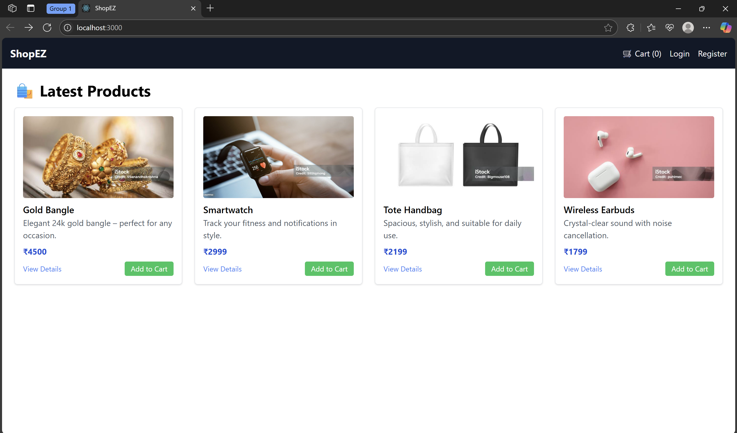

Registration Page
The registration page allows new users to sign up by entering their name, email, and password.
Screenshot:
[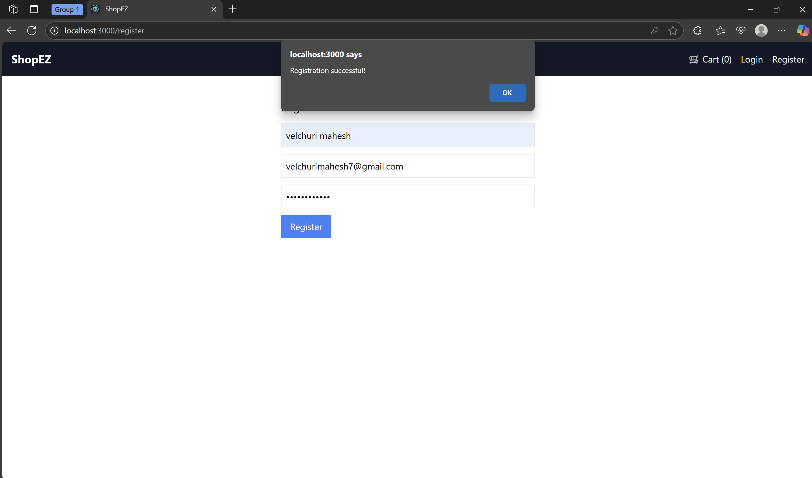

Login Page
Users can log in with their email and password. Upon successful login, the navbar updates to show user status.
Screenshot:
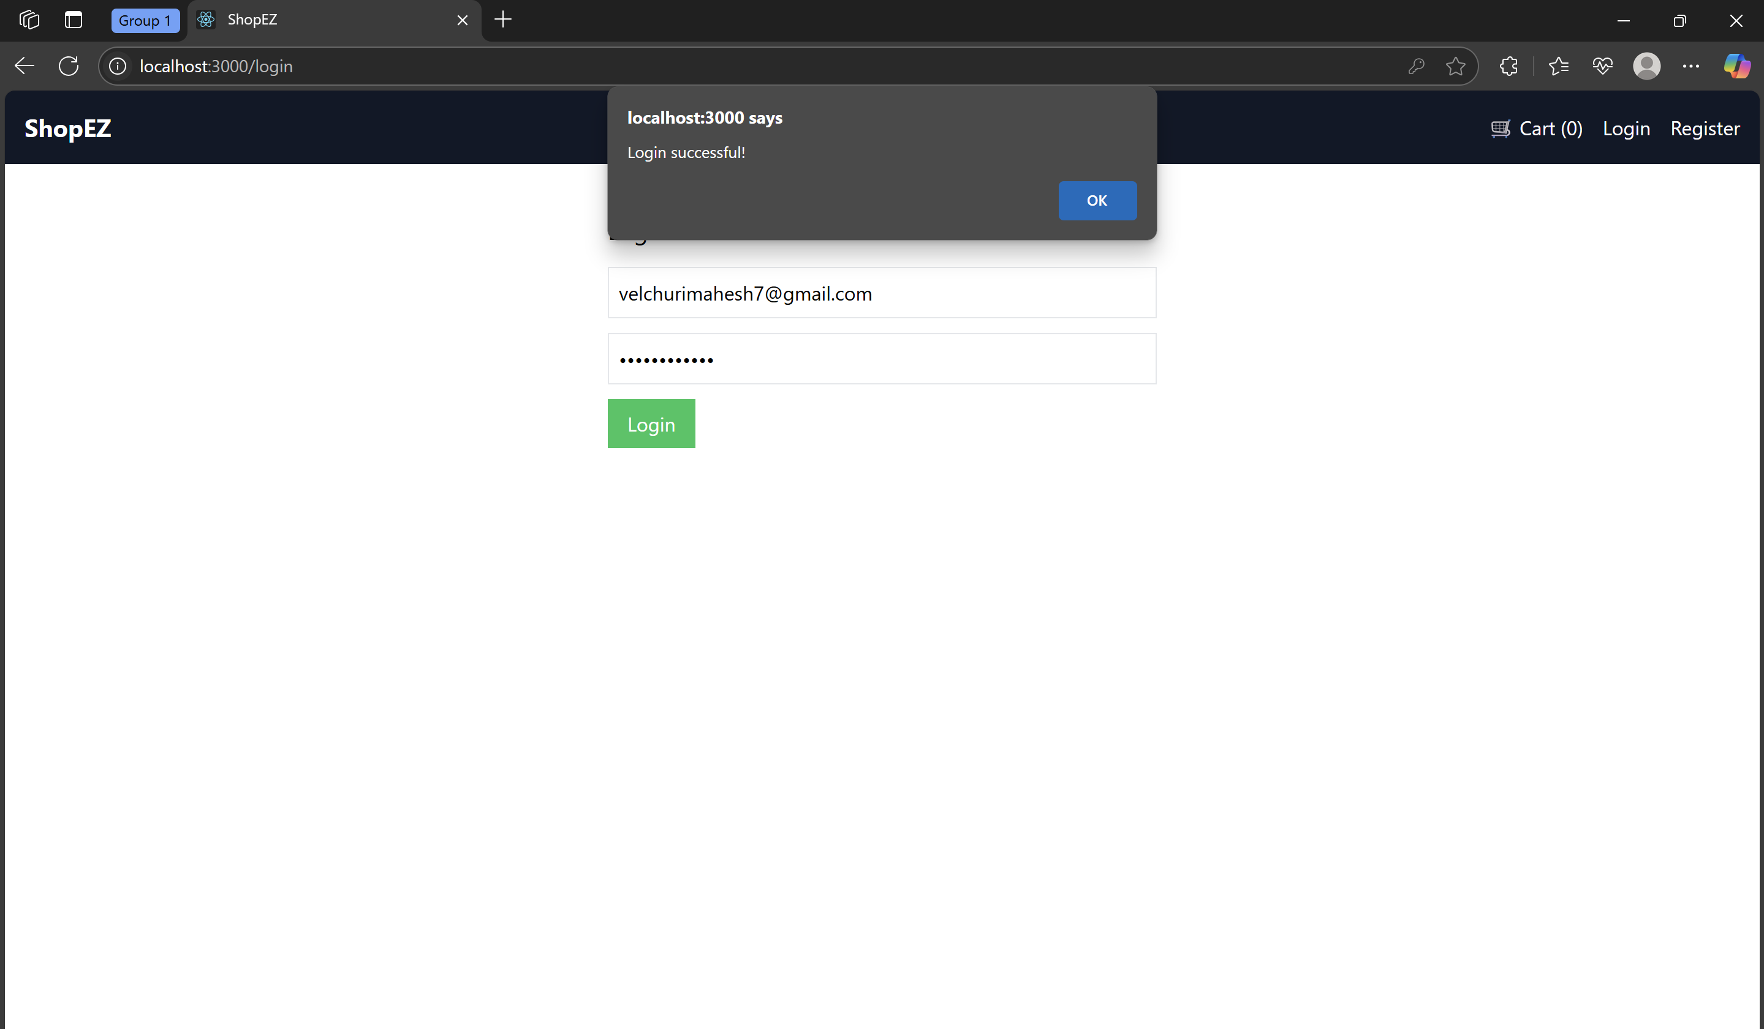

Product Detail Page
Clicking on "View Details" opens a detailed product page that shows a larger image, description, price, and an Add to Cart button.
Screenshot:
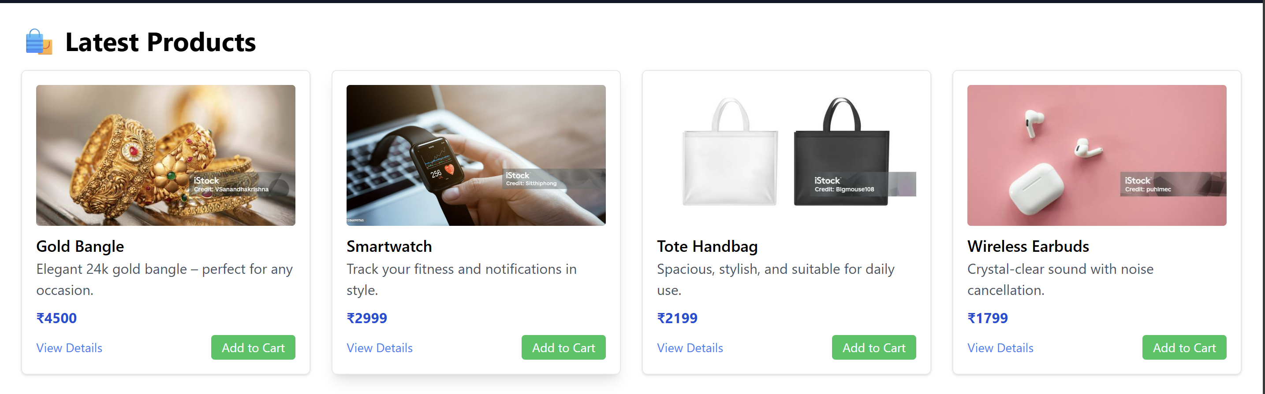
Cart Page
The cart page shows all the items the user has added. Users can remove items or proceed to checkout.
Screenshot:
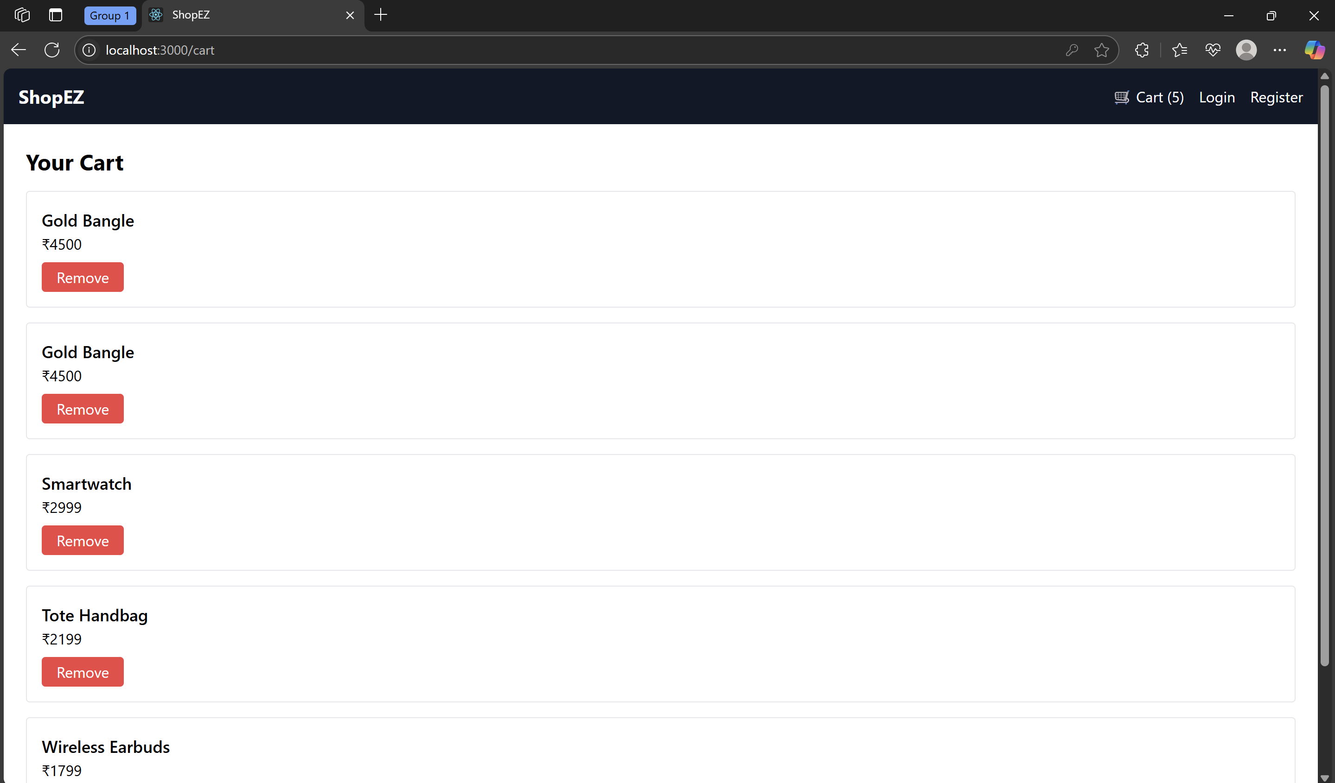
1. Start Backend Server
Make sure you're in the server directory:
cd ShopEZ/server
npm install
npm start
It should say:
Server running on http://localhost:5000

2. Start Frontend React App
Open another terminal and run:
cd ShopEZ/client
npm install
npm start
It should launch on:
http://localhost:3000

Certainly! Here's the positively written version of:

12. Known Issues
While the ShopEZ MERN stack application functions effectively and covers all core features, there are areas identified for enhancement. Addressing these will lead to an even more robust and user-friendly system in future versions.

1. Opportunity: Enhanced Error Handling
- Current Status: Basic error handling is implemented in the backend.
- Enhancement Goal: Implement a global error-handling middleware to provide consistent and informative error responses.
- Positive Impact: Improves developer experience and makes debugging more efficient.

2. Opportunity: Cart Persistence
- Current Status: Cart items exist during the session but are not saved after page refresh or logout.
- Enhancement Goal: Introduce local storage or database support for persistent carts.
- Positive Impact: Enhances user convenience by saving shopping progress.

3. Opportunity: Email Verification
- Current Status: Registration flow is quick and seamless but lacks email verification.
- Enhancement Goal: Integrate an email verification step post-registration.
- Positive Impact: Adds a layer of authenticity and improves user trust.

4. Opportunity: Role-Based Access Control
- Current Status: All authenticated users have equal access.
- Enhancement Goal: Define roles such as admin, seller, and buyer with tailored access.
- Positive Impact: Strengthens application security and enables customized dashboards.

5. Opportunity: User Profile Management
- Current Status: Users are registered successfully but cannot update personal details.
- Enhancement Goal: Add profile edit and password reset features.
- Positive Impact: Increases user satisfaction and data control.

6. Opportunity: Advanced Form Validation
- Current Status: Basic frontend form validation is applied.
- Enhancement Goal: Utilize libraries like Formik and Yup for richer, more secure form handling.
- Positive Impact: Prevents invalid entries and improves data quality.

7. Opportunity: Admin Product Management Interface
- Current Status: Product entries are initially seeded through the backend.
- Enhancement Goal: Add an intuitive admin interface for adding and updating products.
- Positive Impact: Empowers admins to manage the product catalog without technical assistance.

8. Opportunity: Improved Mobile Responsiveness
- Current Status: The application is visually appealing on desktop.
- Enhancement Goal: Optimize styling for smaller screens using responsive design.
- Positive Impact: Ensures a seamless shopping experience across all devices.

Sure! Here's the complete documentation content for:

13. Future Enhancements
As part of continuous development and innovation, several future enhancements have been identified for the ShopEZ MERN stack project. These improvements aim to increase functionality, enhance user experience, and make the platform scalable for real-world e-commerce scenarios.

1. Wishlist Functionality
Description:
Allow users to add products to a wishlist for future reference.
Purpose:
Enhances the shopping experience by letting users save items they are interested in.

2. Product Review and Ratings System
Description:
Enable customers to leave reviews and rate products after purchase.
Purpose:
Improves buyer confidence and provides valuable feedback to sellers.

3. Order History and Tracking
Description:
Implement a detailed order tracking system with delivery status.
Purpose:
Provides transparency and builds trust with customers.

4. Admin Dashboard with Analytics
Description:
Introduce a graphical dashboard for admins to monitor sales, users, and product performance.
Purpose:
Supports business decisions and offers insights into store performance.
Metric | Benefit
Total Sales | Monitor revenue trends
Active Users | Track user engagement
Top Products | Identify best-selling items
Inventory Alerts | Prevent stockouts proactively

5. Coupon and Discount System
Description:
Support promotional codes and discount logic at checkout.
Purpose:
Attracts users and boosts sales during campaigns or festive seasons.

6. Real-Time Chat Support
Description:
Add a chatbox feature for live support and customer queries.
Purpose:
Improves customer service and engagement.

7. Multi-Vendor Support
Description:
Allow multiple sellers to register and manage their own products.
Purpose:
Scales the app into a full-fledged marketplace platform.

8. Payment Gateway Integration
Description:
Integrate with payment services like Razorpay, Stripe, or PayPal.
Purpose:
Facilitates seamless transactions with real currency support.

9. Progressive Web App (PWA)
Description:
Convert the application into a PWA for offline support and native app-like behavior.
Purpose:
Improves performance and accessibility on mobile devices.

10. Push Notifications
Description:
Notify users about order updates, offers, and reminders.
Purpose:
Drives engagement and return visits to the platform.

These future enhancements aim to elevate ShopEZ into a modern, scalable, and user-focused e-commerce application, aligned with industry standards and user expectations.

Conclusion
The ShopEZ project stands as a comprehensive implementation of a modern MERN stack (MongoDB, Express.js, React.js, Node.js) application designed to simulate a fully functional e-commerce platform. Throughout this project, we have successfully integrated critical features like user authentication, product listing, cart management, and dynamic frontend interactions—bringing together both backend and frontend seamlessly.
This project not only showcases the core competencies of full-stack development but also reflects adherence to best practices such as component-based architecture, modular routing, API consumption, and secure data management using JWT authentication.
By building ShopEZ, we have:
- Gained practical experience in building scalable web applications.
- Explored modern UI/UX principles using React.
- Understood RESTful API integration and secure backend communication.
- Learned how to manage state and user context efficiently in complex applications.
- Demonstrated proficiency in tools like Node.js, Express, MongoDB, Postman, and React Router.
While the current version offers core functionalities, there is ample scope for enhancement in terms of UI polish, advanced analytics, real-time features, and deployment scaling.
In conclusion, ShopEZ has been a valuable learning experience and a foundational project that can be extended into a production-level platform. It has helped bridge theoretical knowledge with real-world software development practices, making it a strong portfolio piece for future opportunities in web development.

